EUR/USD Weekly Analysis
I am bearish on this pair, therefore I will only be looking to short this week.
Reason being that on the Daily Chart the 34 is below the 55 MA and price is below the Daily 200 MA and the same for the 4 Hour chart.
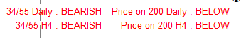
There is also Bearish divergence on the H4 chart which is an early indication of bearish momentum.
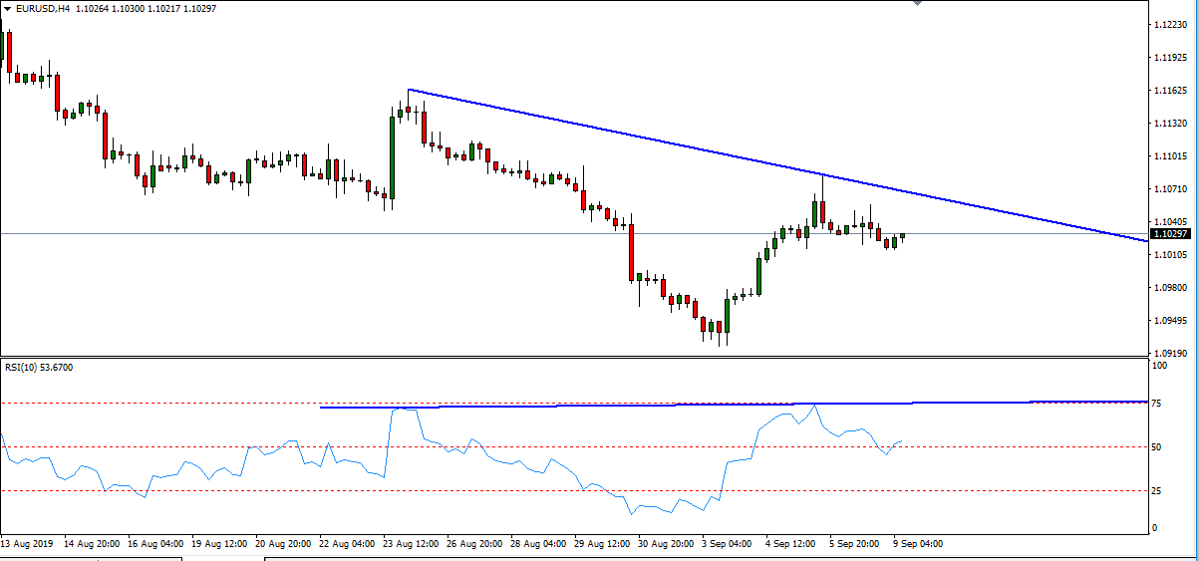

On the Daily:
- 34/55/200 MAs and Bollinger Bands are all facing down
- 5/8 MA cross took place earlier last week (Orange Rectangle) and are starting to consolidate again (Green Rectangle).
- Price has recently just tested the Middle Bollinger/20 SMA (Blue Rectangle).

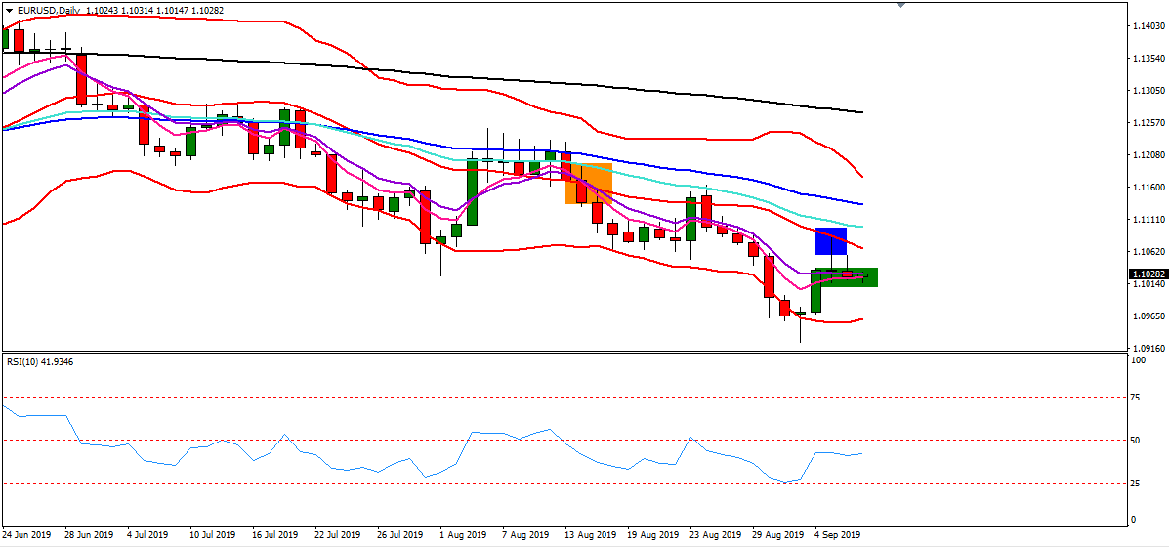

On the 4 Hour Chart:
- 200 MA is facing Down
- 5/8/34/55 MAs as well as price are all consolidating (Orange Rectangle) and Bollingers are busy closing which indicates a range is forming.
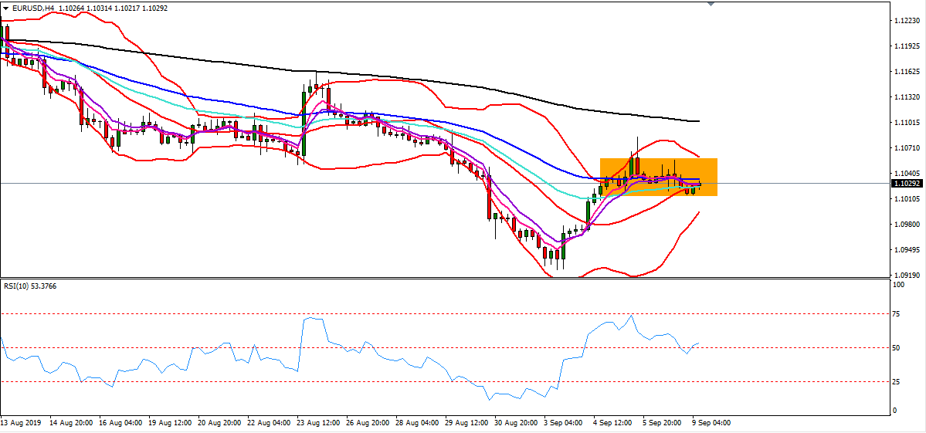
- A break of this Range could mean a big move.

Areas of Interest :
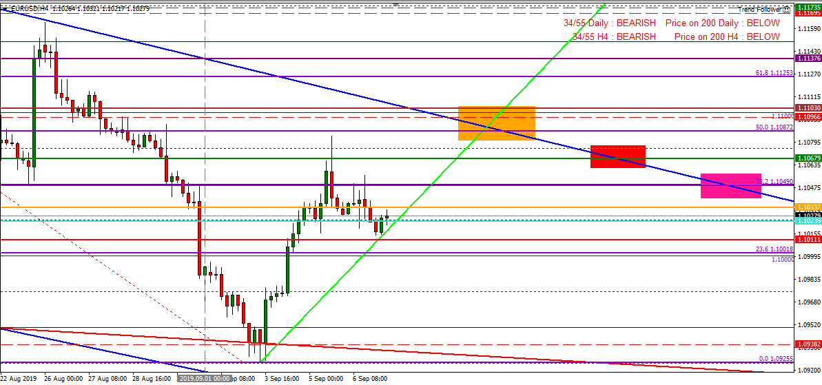

- (Orange Rectangle). I will be looking to short in this area for the following reasons :
  - It is the top of the Daily Trend Channel and there is an intersection between the Daily and H4 Trendlines.
  - Psych level 1.1100 is also in the area and price has reacted at this level many times in the past.
  - Also adding to the resistance is the H4 200MA which is in that area as well as Weekly Pivot Resistance 1.
  - My S/L will be 5 pips above the High of the candle that tests this area.
- (Red Rectangle). I will be looking to short in this area for the following reasons :
  - The top of the Daily Trend Channel is in that area .
  - The big one for me, however, is the Monthly Pivot Point that intersects with the Daily Trendline in that area as price recently has tested the Monthly Pivot.
  - My S/L will be 5 pips above the psych level 1.1075 or the High of the candle that tests this area.

- (Pink Rectangle). ). I will be looking to short in this area for the following reasons :
  - The top of the Daily Trend Channel is in that area .
  - Psych level 1.1050 is in that area and price has recently reacted to this level and tested it as resistance.
  - The 38.2 Fib is also in this area and price has recently respected this level as resistance as well.
  - My S/L will be 5 pips above the high of the candle that tests this area.

- Break of psych level 1.100.
  - Another potential short is a break and pullback at this level.
  - I will personally not take this trade as the Risk:Reward ratio would not look good to me and I must follow my trading rules but I thought I would just point it out incase you guys would be interested in that trade.
  - If I was going to take it my S/L will be 5 pips above the high of the break candle.
*Note: Take Profit Targets will be uploaded when I have confirmed which option I am going to take and I will post my trade management plan as well.*

My Personal Opinion:
I am not much of an economist and I don’t begin to suggest whatever I am predicting is the exact future. However, reading over the fundamentals for the Euro and USD, it seems as though both currencies have a bullish forecast. This could mean some consolidation for a while which makes me lean towards trade options 2 and 3 as price could range until these areas. Option 4 does seem unlikely as economists suggest that EUR/USD will not fall below 1.100, even though, the sentiment for EUR/USD is still bearish. If sentiment had to change to bullish then I will take another look at the markets for longs in the future, however, at this moment I am still only interested in shorting this pair.

