EUR/USD
Last week’s signals were not triggered, as my trendline was not placed properly which is something I can work on so atleast I take that away from last week.
Looking at this week, I am still bearish on this pair, however, I will long if certain important levels are broken. Last week I said that if price reached the 50.0 Fib level then it would fall down and it has reached that level just later than what my initial thought was. Looking at it now it seemed silly that I thought it would move up there so fast but that is another thing I can work on. On H4 chart we are seeing price reacting to this level and looks like a move back down is on the cards.
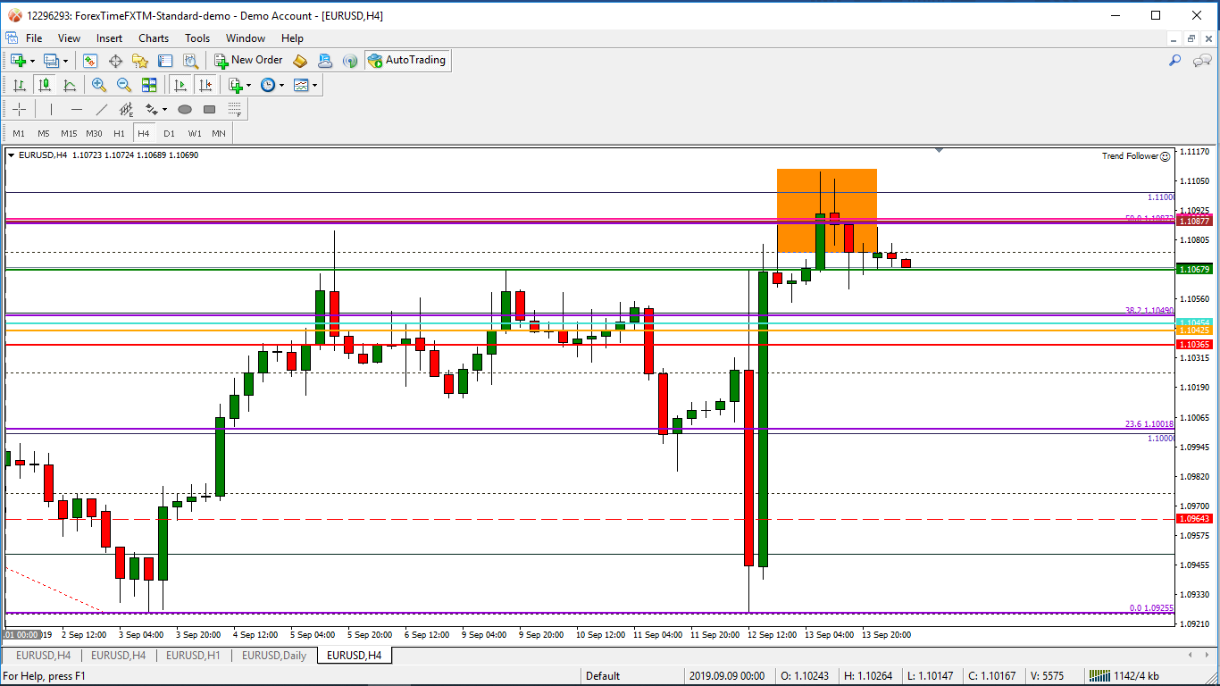
In this area is also the Daily 34 MA, H4 200 MA and the psych level 1.1100 all providing resistance.
This level also contains the Daily trendline that has been holding for a few months
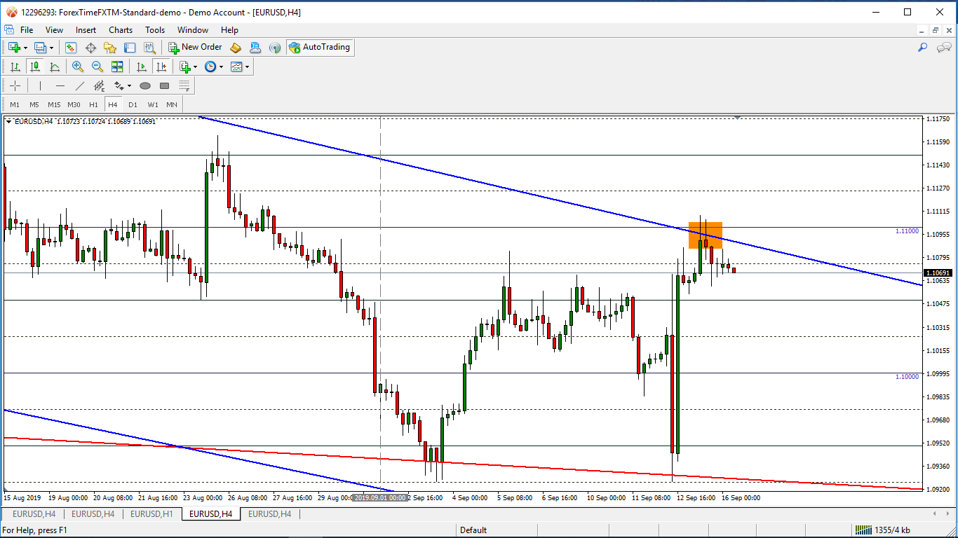
Price has also recently bounced off of the Weekly trendline that has been holding since February 2018.
That is why I will also be looking for a break up this week for longs.

Trades:
- Short:
  - I will short this pair at the break of the Monthly Pivot which was previously strong resistance and is now acting as support as well.
  - My overall target is the bottom Monthly trendline which has been holding since 2008
  - There are many levels in the way of that so I will be taking partial profits at these levels.
- Long:
  - I will long this pair at the break of the 1.1100 psych level which is holding as resistance at the moment.
  - My overall target will be the Daily 200 MA as this up move will probably just be a pullback to the 200 MA but if bullish momentum continues I will hold out for the upper Monthly trendline.
  - I will be taking partial profits at important levels

I hope you enjoy this signal and have a profitable week ahead.

